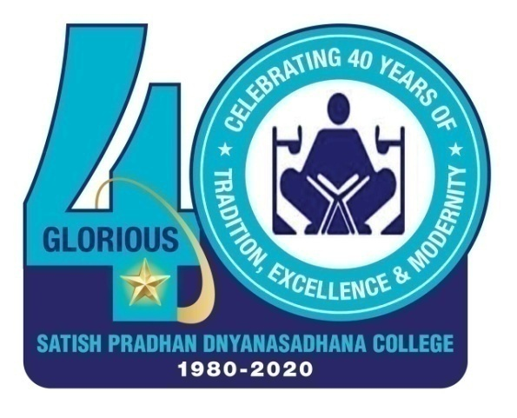 | Satish Pradhan  Dnyanasadhana College, Thane  (Arts, Science and Commerce)  STUDENT DEVELOPMENT PROGRAM (SDP)  E- learning: Blackboard to Broadband
-------------------------------------------------------------------
Deployment Document
As resolved in CDC, a Student Development Program, a quality initiative by IQAC ,SDP Committee in collaboration with Department of Commerce, University of Mumbai was organized on theme “E-learning: Blackboard to broadband.” CDC felt the need to prepare the students for smooth transition from offline to online teaching and learning. The focus was given to empower the students with various e learning tools and techniques.
So various committees were formed for planning, execution and implementation of SDP.
Advisory committee:
Shri Satish Pradhan, President Dnyanasadhana
Shri Kamlesh Pradhan- secretary
Shri Satish Sheth- Treasurer
Mrs Manasi Pradhan- Trustee
Chairpersons:
Dr C.D Marathe Principal, Satish Pradhan Dnyanasadhana College
CMA,Dr.KinnarryThakkar (Prof & Head, Dept. of commerce, University of Mumbai)
Convenors:
Dr Bhushan Langi
Dr Anita Dakshina
Dr Shraddha Bhome
Coordinators:
Ms. Vaishali Gavandi
Mr. Dinesh Joshi

Various sub committees for the smooth functioning of the event.

1. Resource Persons Coordination: Dr.Shraddha Bhome , Dr.Anita Dakshina, Dr.Bhushan Langi & Mr.Suyash Pradhan
2. Maintaining Telegram group: Mr.Shirish Lele
4. Communication in groups: Dr.Anita Dakshina , Dr. Shraddha Bhome, Dr.Bhushan Langi
5. Help desk: IT/ CS teachers
6. Feedback and analysis committee: IT/ CS department
7. Student’s Committee Coordinator: Dr.Radhika Mukherjee, Ms.Sneha Thakkar & Mr. Dinesh Joshi
8. College Coordination: Dr.Babasaheb Kambale, Dr.Sachin Puranik
9. Records Maintaining: Ms.Varsha More, Ms.Prachi Bakle
10. Distance Learning Student’s coordination: Mr.Dhananjay Pasthe
11 Students coordinator: Ms.Jagruti Sharma

Since the objectives of the programme was to facilitate online platform for the learners. Knowledgeable and experienced resource persons were taken on board. There was a team of 38 students. Training was given to the students by their mentors to improve their presentation, technical and soft skills. This programme was for the students, by the students and of the students.
ANCHORING COMMITTEE: Mentors were Ms.Sarika Sagar, Dr.Afreen Eksambi, Ms.Runa Shajeev, Dr.Radhika Mukherjee.

SR. NO | NAME OF THE STUDENT | CLASS | MOB NO
1 | Priti Barje | SYBBI - A | 7715879835
2 | Akshata S Padwal | SYJC (COM) | 9769291627
3 | Jui Pravin Sawant | FYBAF - B | 7518504298
4 | Ksheera Shetty | TYBCOM | 9867675106
5 | Maheshwari Patil | FYBSC | 8454934217
6 | Rohan Mahesh pathare | TYBSC | 8898943026
7 | Sagar Tawde | FYBBI - B | 9867051416
8 | Sakshi Trivedi | TYBCOM - A | 7021653509
9 | Yashita Parab | SYBSC IT | 9892940013
10 | Jagruti Sharma | TYBCOM | 8419948094
11 | Ishita Mundley | SYJC (COM) | 8104158986
12 | Vedanti Gide | SYJC (COM) | 9594311966
13 | Gandhali Kudtarkar | SYBMS - A | 9960382651
REGISTRATION AND CERTIFICATE COMMITTEE: Mentors were Dr Sachin Puranik, Mr.Manoj Wagh, Mr. Swapnil Talekar, Mr.Mangesh Kharatar,

1 | Chaitali Golwalkar | TYBCOM | 9869984856
2 | Shubham Kishore Sarangule | SYBA | 9869703687/8108813529

IT TECHNICAL SUPPORT COMMITTEE: Teacher mentors were Mr. Abhinandan Sawant, B.Sc IT/ CS all professors
1 | Gaurav Yadav | 12th | 8928844120
2 | Rahul Borhade | 12th | 9324386766

MEDIA PUBLICITY COMMITTEE: Teacher Mentors were Mr.Mahesh Kulsunge (Marathi Script), Ms.Kanika Arya ( Coverage), Ms.Runa Shajeev ( English Script)

1 | Sanket Anant More | TYBAFTNMP | 8828019121
2 | Kunal Laxman Sawant | SYBA | 7715832598
3 | Shruti Panjiri | FYBAMMC | 8928999842
4 | Priti Patkar | SYBMM | 7506092291

PROMOTION COMMITTEE: Teacher mentors were Ms.Kanika Arya, Mr.Rajesh Valecha, Mr.Jitendra Haldankar

1 | Pratik Tathe | FYMBS | 8879872002
2 | Varun Mahabadi | SYBMS - B | 9022419457
3 | Jagruti Sharma | TYBCOM | 8419948094
4 | Hrishikesh Kokate | SYBMM | 8879833650
5 | Hrushikesh Bariya | SYBMM | 8652789792
6 | Nilam Sonar | SYBMS - B | 8369389051
7 | Justin Karande | SYBMS - B | 9867779850
8 | Samrudhi Sonavale | FYBMS | 9067911681
9 | Harshal Vijay Atkari | BAFTNMP | 7977145123
10 | Veerbhadra Bhuoesh More | BAFTNMP | 7506833889
11 | Harsh Khapedkar | BAFTNMP | 9769212043

INHOUSE STUDENTS COORDINATION COMMITTEE: Teacher mentors were Dr.Manisha Bhingardive, Dr.Mandakini Ingle, Mr.Pravin Tiwad, Ms.Siddhi Patil, Ms.Prachi Bakle

1 | Anuja Chinkate | M. Sc Part 1 (Botany) | 7900004932
2 | Gaurang Shinde | 12th | 7710044239
3 | Gauri Karande | SYBAF | 8291798084
4 | Sonali Patil | TYBA - Sociology | 7738755577
5 | Tanvi Thosar | TYBCOM - A | 7303239696
6 | Yukta Tiwari | 12th | 9769129208
7 | Zarin Khopekar | M. Sc Part 1 (Botany) | 9373097227

SCHEDULE : 30/6/2020 to 6/7/2020

PARTICIPANTS: 28,188 students from all over India and abroad. 184 were from abroad: Kuwait (103), Nigeria (3) Nepal (56), Saudi Arabia (09) , Oman (4), UAE ,Indonesia (2) and one from Ghana, Philippines, UK , Qatar and Bhutan.
Day wise topics and its links
Daywise Topics & YouTube links of Students Development Program (SDP) –
E-learning from Blackboard To Broadband.
Day - 1 - Topic - From The Desk of a Motivator https://www.youtube.com/watch?v=BU_m37nDyYk
Day - 2 - Topics - Cyber Security, Internet Banking & Payment Apps https://www.youtube.com/watch?v=KP2DskaD19g
Day - 3 - Topics - Understanding MS-Word & Power Point Presentation, Stress Coping Mechanism https://www.youtube.com/watch?v=wX022Rk_Ju8
Day - 4 - Topics - MS-Excel, Free Apps & Mobile Video Making https://www.youtube.com/watch?v=RQgZCnFOYqg
Day - 5 - Topics - Different Online Platforms & Courses For E-learning, Success Stories of Achievers & Millennials https://www.youtube.com/watch?v=R7ip8va3VFA
DAY - 6 - Topic - Explore Google & Google Classroom https://www.youtube.com/watch?v=awXErKMPfaE
Day - 7 - Topics - Content Writing, Digital Marketing https://www.youtube.com/watch?v=nAK5Jo-C8Cs

Some glimpses of the programme:
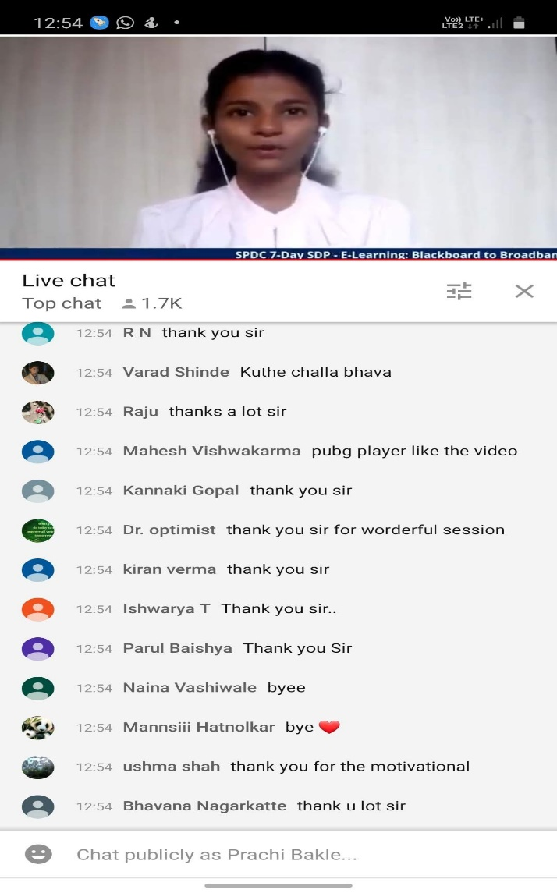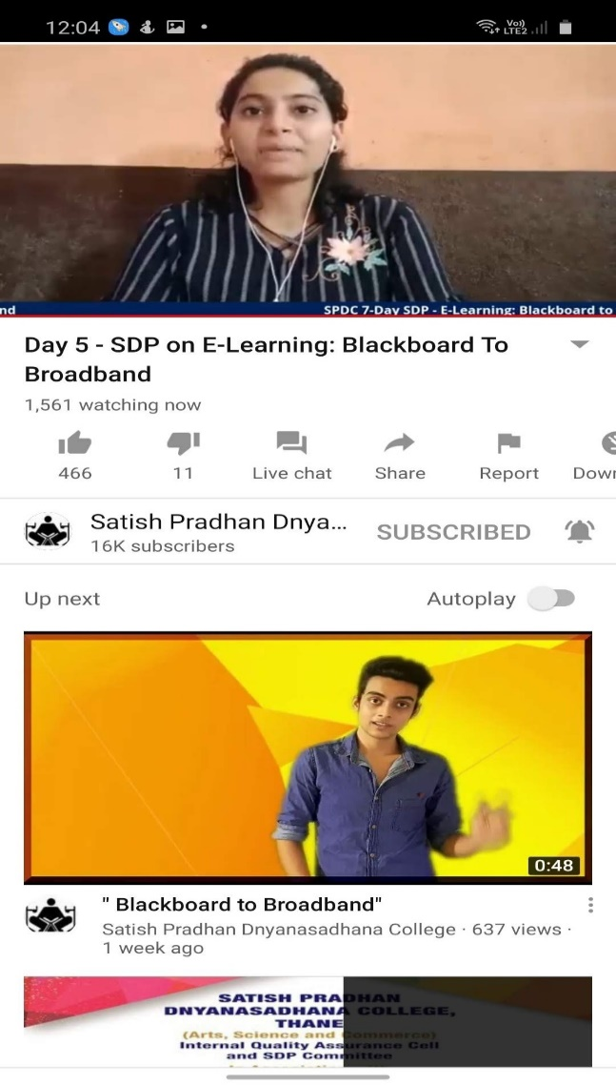
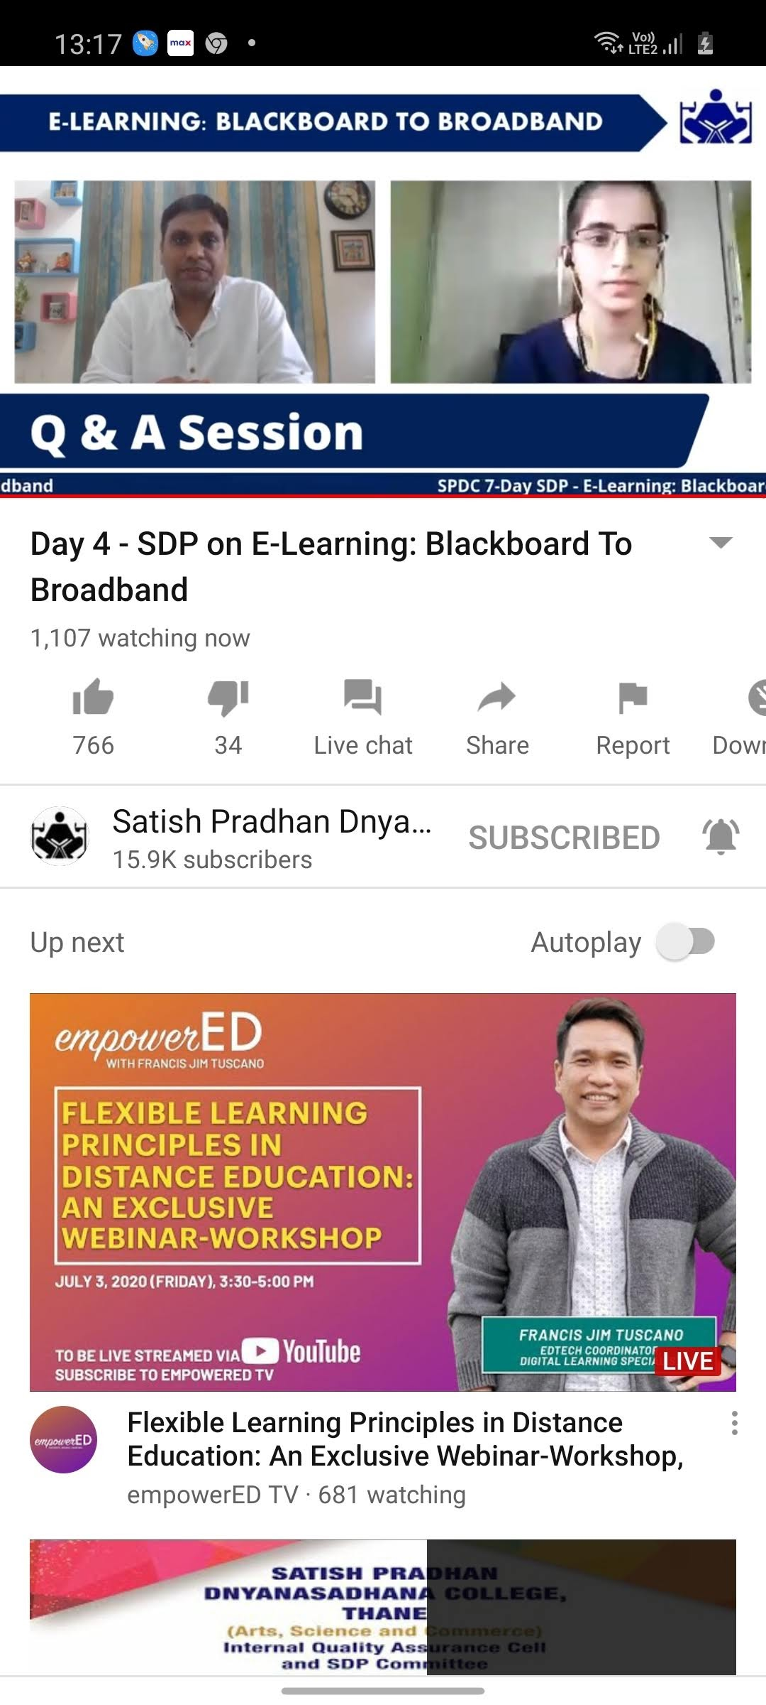

Convenors:
Dr. Bhushan Langi
Dr. Shraddha Bhome
Dr. Anita Dakshina

